**// Create a Stack ADT using Linked List Data structure and perform its operations**

#include<iostream.h>

#include<conio.h>

struct Node{

int data;

Node *link;

};

Node *top=NULL;

void push(int val){

Node *ptr = new Node();

ptr->data = val;

ptr->link = top;

top = ptr;

}

void pop(){

if(top!=NULL)

cout<<"the popped element is :"<<top->data<<endl;

if(top==NULL)

cout<<"Stack is Empty"<<endl;

else{

Node *ptr = top;

top = top->link;

delete(ptr);

}

}

void peek(){

if(top==NULL)

cout<<"stack is empty"<<endl;

else{

cout<<"\n Value in the stack is :";

Node *temp =top;

while(temp!=NULL)

{

cout<<temp->data<<"->";

temp = temp->link;

}

cout<<"\n";

}

}

void main() {

clrscr();

int option, val;

cout<<"\n STACK ADT OPERATIONS USING LINKED LIST \n";

cout<<"1) Push an element into stack"<<endl;

cout<<"2) Pop the last element stack"<<endl;

cout<<"3) Display the stack"<<endl;

cout<<"4) Exit"<<endl;

while(option!=4) {

cout<<"Enter choice: "<<endl;

cin>>option;

switch(option) {

case 1: {

cout<<"Enter value to be pushed:"<<endl;

cin>>val;

push(val);

break;

}

case 2: {

pop();

break;

}

case 3: {

peek();

break;

}

case 4: {

cout<<"Exiting.."<<endl;

break;

}

default: {

cout<<"Invalid Choice"<<endl;

}

}//switch case ends here

}//while loop ends here

}//void main ends here

**OUTPUT:**

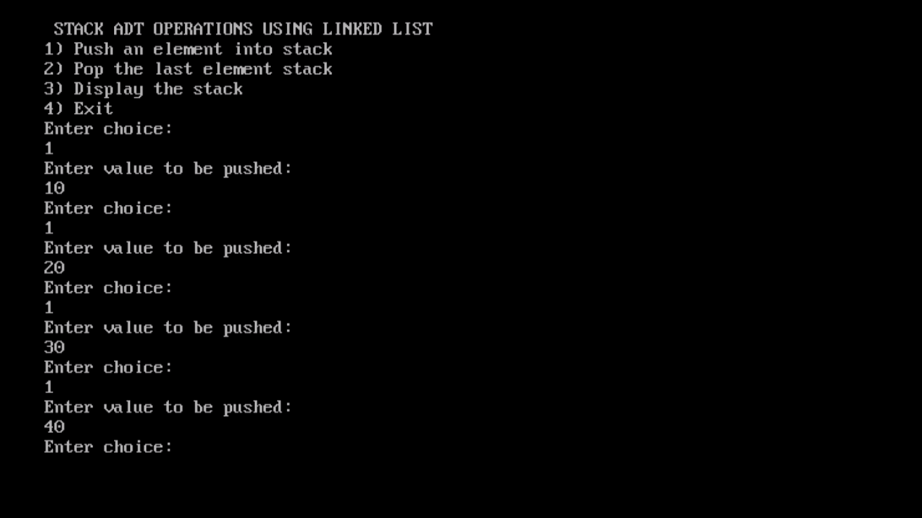

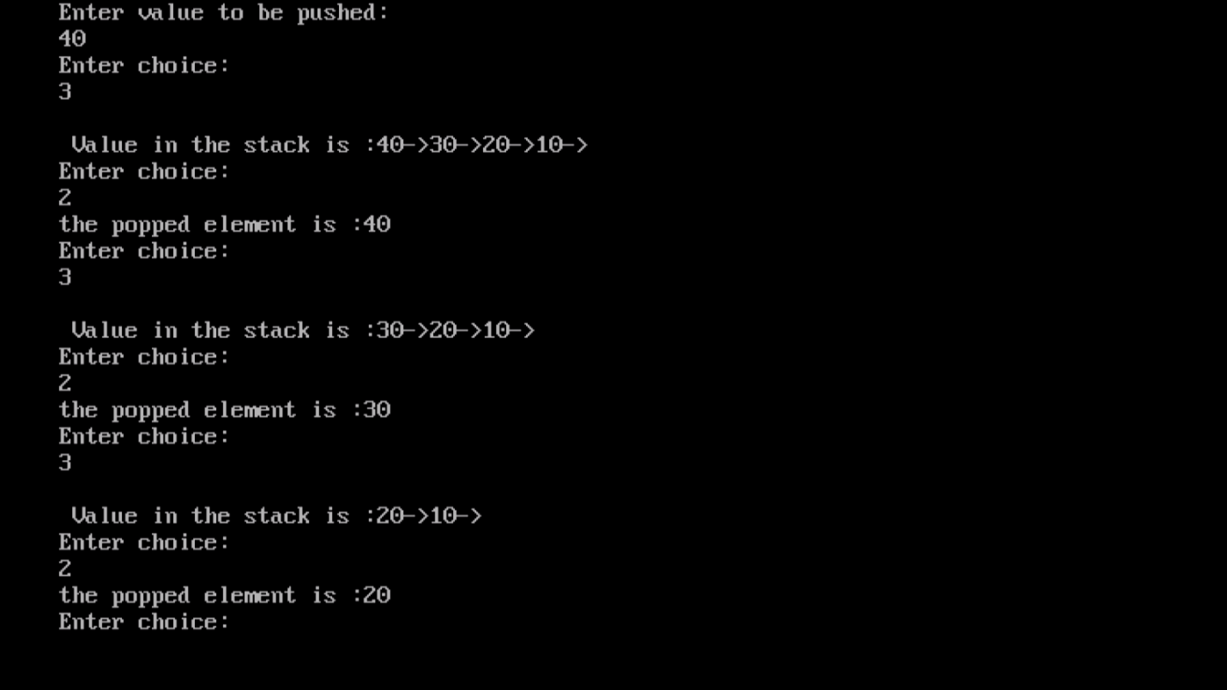

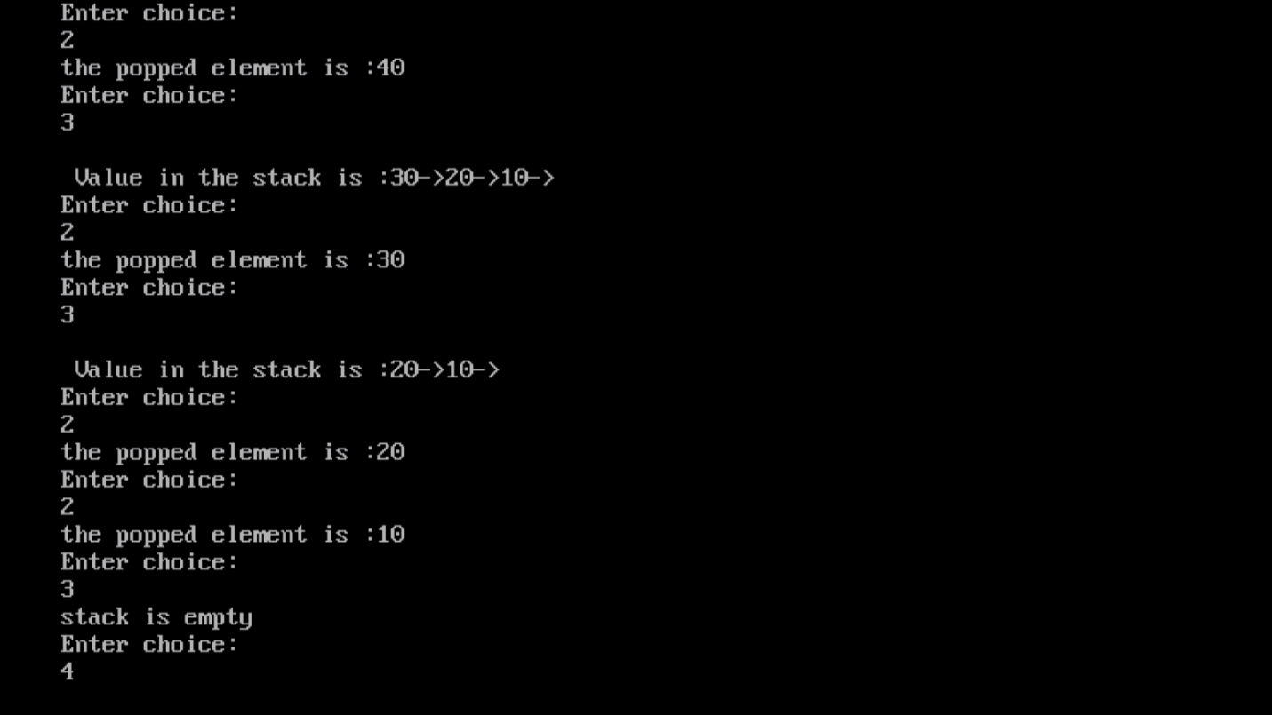

**//This code was contributed by Vijeyandrian MCA Section ’B’**